REPORT: Recognizing Textual Entailment

Kaustubh r Deshpande

AIM:
Implementing a deep learning model that recognizes the textual entailment relation between two sentences given two sentences: the premise, denoted by the letter t and the hypothesis, denoted by the letter h. True if t-> h (t entails h) , false otherwise.

Results:

Train.xml
Model: "sequential"
_________________________________________________________________
Layer (type) Output Shape Param #
=================================================================
embedding (Embedding) (None, None, 64) 426048
_________________________________________________________________
dense (Dense) (None, None, 8) 520
_________________________________________________________________
dense_1 (Dense) (None, None, 1) 9
=================================================================
Total params: 426,577
Trainable params: 426,577
Non-trainable params: 0
_________________________________________________________________
Train on 567 samples
Epoch 1/5
567/567 [==============================] - 1s 2ms/sample - loss: 1.9906 - binary_accuracy: 0.0000e+00
Epoch 2/5
567/567 [==============================] - 0s 83us/sample - loss: 1.0876 - binary_accuracy: 0.3675
Epoch 3/5
567/567 [==============================] - 0s 83us/sample - loss: 0.6397 - binary_accuracy: 0.4817
Epoch 4/5
567/567 [==============================] - 0s 83us/sample - loss: 0.4544 - binary_accuracy: 0.4991
Epoch 5/5
567/567 [==============================] - 0s 92us/sample - loss: 0.3832 - binary_accuracy: 0.4991
567/1 0s 468us/sample - loss: 0.3946 - binary_accuracy: 0.4991
result is
[0.3617420717942441, 0.49911818]

Test.xml
Train on 360 samples
result is
[0.6424032502704197, 0.5]

Changing epoch value to 10:
Train on 567 samples
Epoch 1/10
567/567 [==============================] - 2s 3ms/sample - loss: 2.0693 - binary_accuracy: 0.0000e+00
Epoch 2/10
567/567 [==============================] - 0s 91us/sample - loss: 1.2669 - binary_accuracy: 0.2244
Epoch 3/10
567/567 [==============================] - 0s 91us/sample - loss: 0.8018 - binary_accuracy: 0.4656
Epoch 4/10
567/567 [==============================] - 0s 92us/sample - loss: 0.5472 - binary_accuracy: 0.5009
Epoch 5/10
567/567 [==============================] - 0s 91us/sample - loss: 0.4218 - binary_accuracy: 0.5009
Epoch 6/10
567/567 [==============================] - 0s 90us/sample - loss: 0.3630 - binary_accuracy: 0.5009
Epoch 7/10
567/567 [==============================] - 0s 90us/sample - loss: 0.3374 - binary_accuracy: 0.5009
Epoch 8/10
567/567 [==============================] - 0s 91us/sample - loss: 0.3247 - binary_accuracy: 0.5009
Epoch 9/10
567/567 [==============================] - 0s 92us/sample - loss: 0.3172 - binary_accuracy: 0.5009
Epoch 10/10
567/567 [==============================] - 0s 65us/sample - loss: 0.3119 - binary_accuracy: 0.5009
567/1
0s 603us/sample - loss: 0.2936 - binary_accuracy: 0.5009
result is
[0.3090517141411124, 0.50088185]

result is
[0.3491406791739994, 0.5]

Loss has decreased , but accuracy has not increased (accuracy was expected to increase with increase in epoch value)

Changing batch value:

Batch changed from 100 to 50
Training: sample - loss: 0.2849 - binary_accuracy: 0.5009
Testing: sample - loss: 0.3370
result is [0.31306100090344746, 0.5]

Training loss has reduced by decreasing the batch size. Not much changes in accuracy.

Adding LSTM layers:

Errors obtained during adding of further LSTM layers , could not solve it in the time given. Error with dimensionality of the input/output vectors in the bidirectional layer of LSTM

OUTPUT screenshots:

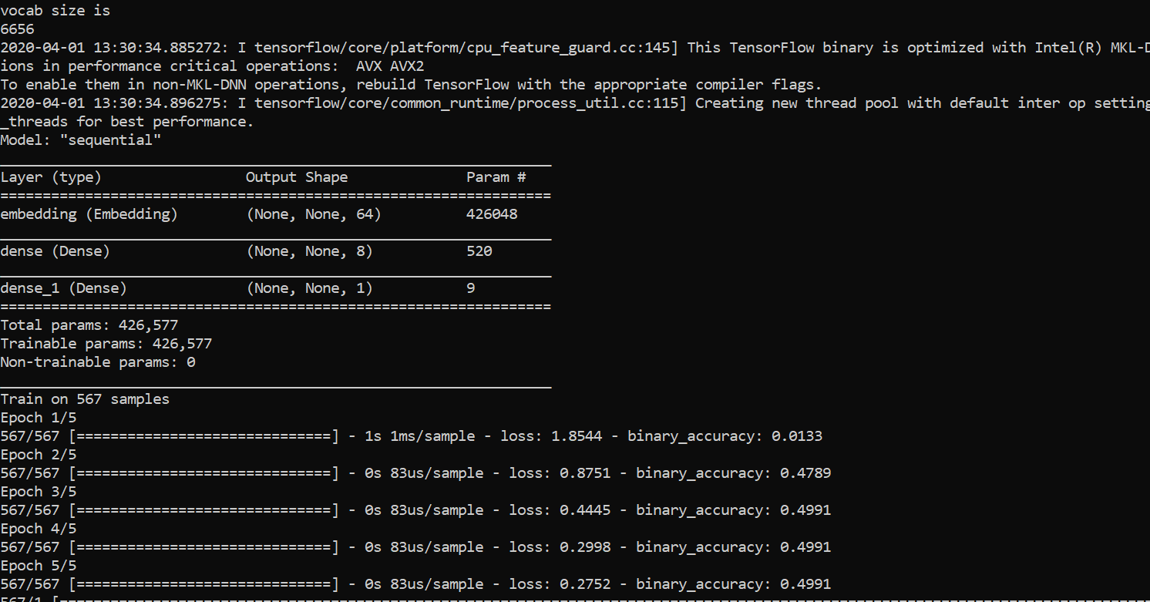

Test data:
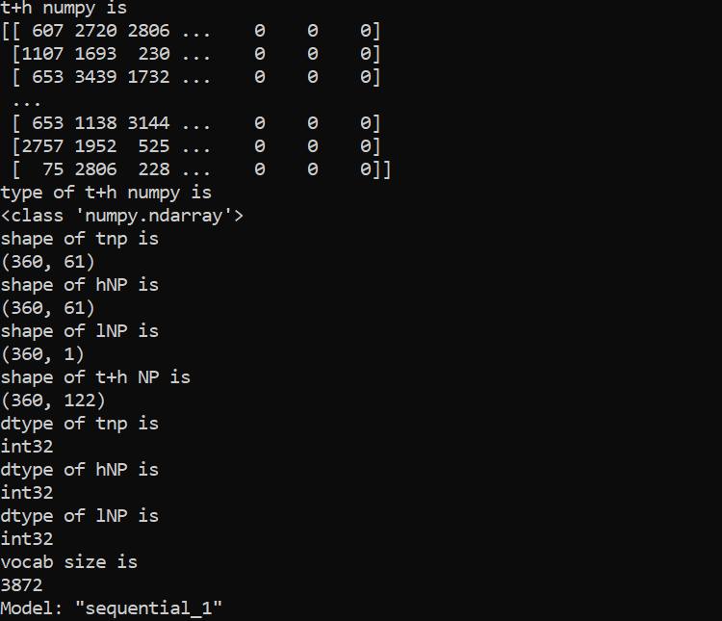

References:

- Thank you Mr. Takshak desai for your guidance . Thank you for helping out of this project. I found it really hard to look for examples and learn from tutorials. This project is still not upto the mark and I accept it, yet I am happy to achieve some sort results out of this endeavour ! I wish to improve and indulge in many more such projects in the future

- https://www.tensorflow.org/api_docs/python/tf/data/Dataset
- https://www.tensorflow.org/api_docs/python/tf/data/experimental/sample_from_datasets
- https://heartbeat.fritz.ai/using-a-keras-embedding-layer-to-handle-text-data-2c88dc019600

